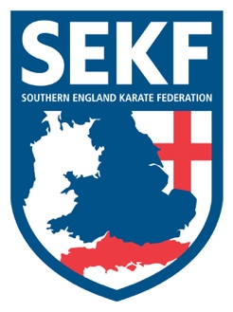
Newsletter October 2019
September has been another busy month for the SEKF…. Firstly, I would like to congratulate all the Instructors / Mentors who attended the recent Mentor course and were selected to represent the SEKF. They are easily spotted at the classes due to their eagerness to help others and their Navy Blue “Train with the Champions’ polo shirts.
The Elite squad has been very active throughout September. They attended the British International Open in Scotland and it was a great success. Our four athletes managed to win a staggering 3 Silver medals.…. Amazing!
The above articles and other news/events are on our website at www.sekf.co.uk

Saturday course for Poole area students
There will be a special course on Saturday 12th October at the Ashdown Leisure Centre, (Adastral Rd, Canford Heath. BH17 8PY).
This course will be aimed at stances and perfecting the new kata for your next belt (or tag) and is important if you wish to grade in December.
White to Green tag - 10.00am – 11.00am
Green Belt & Above - 11.00am – 12.00pm

Saturday course for New Forest area students
There will be a special course on Saturday 12th October at New Milton Health & Leisure Centre, (Gore Road, New Milton BH25 6RR).
This course will be aimed at stances and perfecting the new kata for your next belt (or tag) and is important if you wish to grade in December.
White & Red belts - 2.00 – 3.00pm
Yellow belt to Green tags - 3.00 – 4.00pm
Green belt & Above - 4.00 – 5.00pm

Advanced Course
There will be an advanced course for Blue belt & above, and Squad members only, to be held at New Milton Health and Leisure Centre. (Gore road, BH25 6RR). This course is vital for advanced students wishing to grade in December.

Date: Sunday 13th October Time: 11.15am – 1.15pm Cost: £15.00

COLLIN - collinrudkin@gmail.com - 07966 303585
DANNY - 07813 329 710

