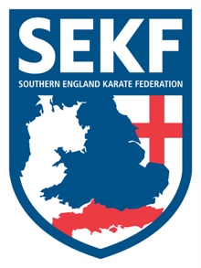
School Fees Letter

Dear parents

The primary school karate fees are now due for the 2nd half of the summer term:
Week commencing Monday 7th June – Week ending Friday 16th July

Total six weeks plus two Saturday courses = £60.00
(Saturday grading course dates: Saturday 19th June / Saturday 10th July)

Please make payment to the bank account details below prior to Friday 4th June to reserve your child’s place, adding your child’s name and the school code as payment reference.

Payment details:
Name: Freestyle Combat Karate
Account No: 50134759
Sort Code: 20-68-79

Primary School codes for payment refence:

- TW - Twynham Primary school
- AJS– Ashley Junior School
- BR– Bransgore Primary school
- BN– Burton Primary school
- SM – St Marks primary school
- SL – St Lukes Primary school
- MIL – Milford Primary School
- LJS - Lymington Junior School

If you have any queries, please do not hesitate to contact me

Sensei Collin: 07966 303 585
www.sekf.co.uk

